MEMORANDUM

TO: Instructor Name; TA Name

FROM: Tanisha Lahiri; Riley Park
(Section 028; Group 7)

DATE: 9/25/2026

SUBJECT: Lab 1: Material Identification via Tensile Testing

TECHNICAL OBJECTIVE

The purpose of this lab was to identify 6 materials based on their mechanical properties. These properties were found via tensile testing, finding the material properties by destructively testing samples. These properties were then used to match materials to published material properties, determining which materials fit within the derived parameters.

MATERIALS AND METHODS

Each material property was measured using tensile testing. The machine used in this specific experiment was the INSTRON Tensile Tester, running a custom test profile. The main parameter that was controlled was the displacement rate (mm/min). Each sample was marked at the points at which they were secured to the grips of the machine. After securing the sample, zeroing the sensors, and inputting the given displacement rate (Found in Table 1), the test was run. There were 6 iterations of the test run for materials A through F. Further testing was performed on material F, altering the displacement rate to determine a difference in material response. Additionally, video was recorded for material A; however, due to data corruption, the video could not be used in this experiment.
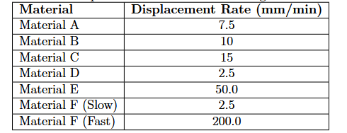
Table 1: Displacement rates for each material

Upon completion and collection of data, the data was consolidated and calculated using a Jupyter notebook. This notebook was used to plot Stress/strain diagrams, and calculate ultimate stress, ultimate strain, yield stress, and Young’s modulus for each sample.

RESULTS

The tensile testing performed on the INSTRON Tensile Testers produced files for each material (noted as Materials A-F), containing test times (seconds), displacements (millimeters), and forces (Kilonewtons) in a CSV format. Additional tests were performed on materials A and F; materials A was recorded both in CSV and Video(AVI) formats; material F was tested twice, once with a slow displacement rate, and once with a fast displacement rate. The displacement rates for each material can be found in Table 1, found in the tensile testing lab instructions.
Using the extracted CSV files detailing the materials’ response to tensile testing, the material properties of each material were calculated and plotted, as seen in Figure 1 through Figure 7.
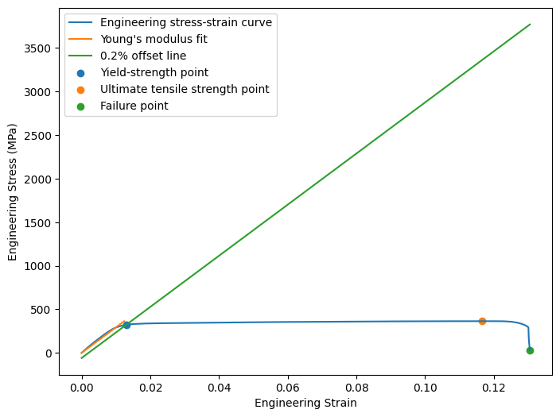
Figure 1: Material A displacement
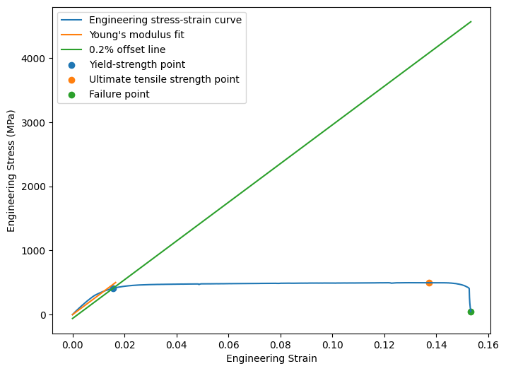
Figure 2: Material B displacement
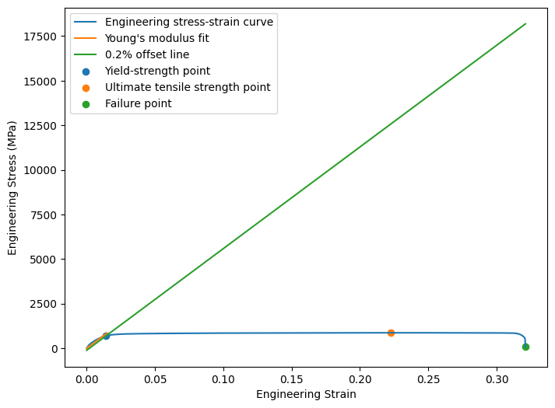
Figure 3: Material C displacement
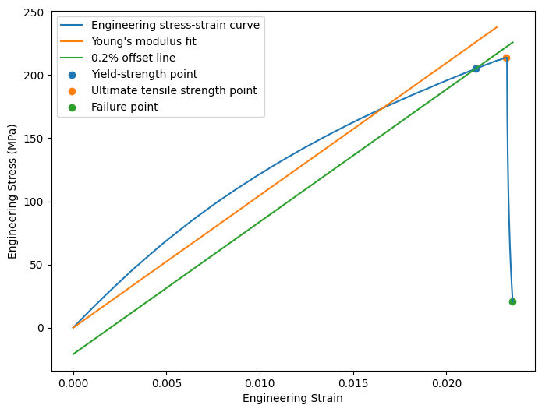
Figure 4: Material D displacement
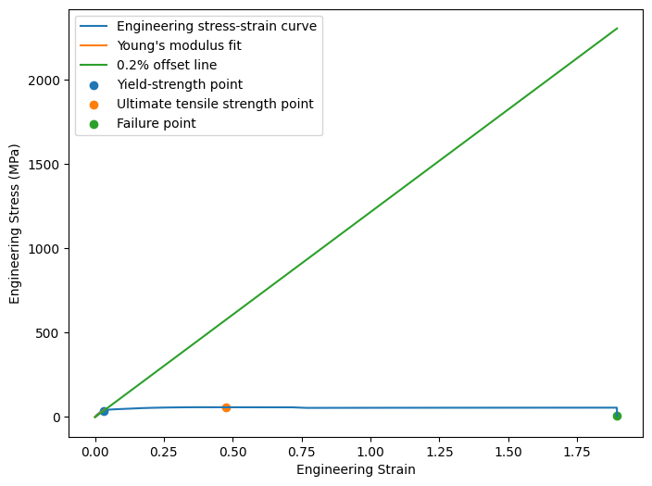
Figure 5: Material E displacement
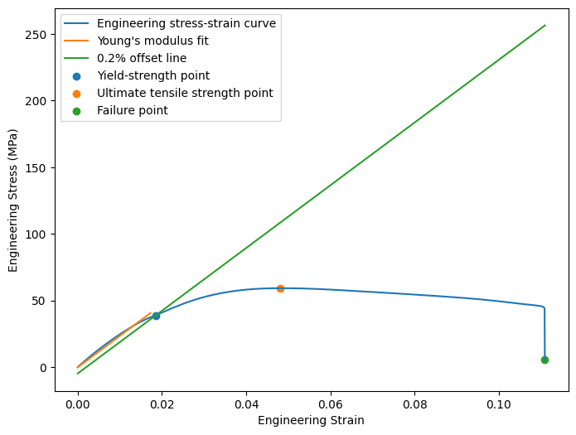
Figure 6: Material F displacement (slow)
The graphs of these figures show that each material had a distinct response to the given displacement rates, which allowed calculations to be made to determine their material properties.
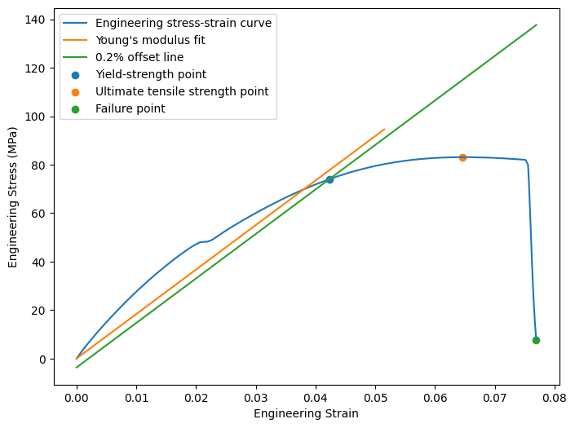
Figure 7: Material F displacement (fast)
Additionally, the stress/strain curves for both tests of material F were compared to each other, as seen in Figure 8.
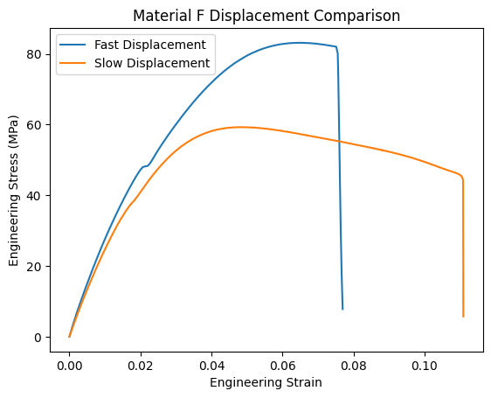
Figure 8: Material F, fast vs slow displacement
With the calculated material properties of each material, each material could be categorized by their best properties, and fit to their likely material categories, as seen in Table 2.
ID | Characterization | E (GPa) | σy (MPa) | σu (MPa) | εu | Material
A |  | 29.332 | 322.648 | 364.202 | 0.131 | Aluminum
B |  | 30.155 | 410.632 | 498.326 | 0.153 | Brass
C | Strongest, Stiffest | 56.984 | 700.605 | 867.555 | 0.321 | Stainless Steel
D | Toughest | 10.482 | 205.057 | 213.798 | 0.024 | Garolite
E | Most brittle,  ductile | 1.216 | 36.856 | 57.444 | 1.895 | Acrylic
F |  | 2.353, 1.216 | 38.788, 36.856 | 59.275, 57.444 | 0.111,0.077 | Nylon
Table 2: Material parameters found through tensile testing
Some materials properties had significant overlap, as was the case with materials A and B; however, this could be compensated by relying on the materials’ other performance metrics.

DISCUSSION AND CONCLUSIONS
After the data was collected from the tensile testing, the properties were calculated, and output to Table 2. They were categorized by their best material characteristics in column 2, and their corresponding materials in column 7. When comparing the sample materials to the published materials, the properties of Material C were the strongest fit, strongly correlating to the properties of Stainless Steel, while the properties of material brass had the weakest correlation. These errors could have been caused by mechanical errors in experimentation, such as weak clamping force, improper marking of gripped intervals, or inconsistent diameter. There were no significant outliers in the data, as the material properties directly correlated with their corresponding performance under load. The metallic materials, with higher elasticity and ultimate strains, experienced far less elongation than the non-metallics, and had far more dramatic released forces upon failure. The non-metallics notably displayed much more necking, and had greater strain compared to the metallics. This led to less linear elastic response, as the cross section experienced greater alteration.
Additionally, the results from the experiment in altering displacement rates can be seen in Figure 8. The graph shows that Material F responds differently to different displacement speeds; lower speed leads to greater elasticity and ultimate strain, at the cost of overall stress. This implies that, at least for Material F, decreased displacement rates would lead to greater strain and lower stress, allowing for more displacement.
These findings show that testing for material properties is one way to accurately determine the material makeup of a given sample. By using tensile testing, this experiment produced the Young’s modulus, ultimate strength, ultimate strain, and yield strength of the samples, which proved to be more than enough to accurately identify them. Application of this principle to other mechanical properties is expected to follow the same pattern; by determining a samples properties, the material makeup can be derived.

REFERENCES

- M. F. Ashby, “The elastic modulus of engineering materials,” Journal of Materials Science, vol. 18, no. 5, pp. 1235–1240, 1983.
- Overleaf. “Bibiography management with biblatex.” (2024), [Online]. Available: https://
www . overleaf . com / learn / latex / Bibliography _ management _ with _ biblatex # Reference_guide (visited on 07/18/2024).
- Overleaf. “Aligning equationgs with amsmath.” (2025), [Online]. Available: https://www. overleaf.com/learn/latex/Aligning_equations_with_amsmath (visited on 01/20/2025).
- Overleaf. “Inserting images.” (2025), [Online]. Available: https://www.overleaf.com/ learn/latex/Inserting_Images (visited on 01/20/2025).
- Overleaf. “Tables.” (2025), [Online]. Available: https://www.overleaf.com/learn/ latex/Tables (visited on 01/20/2025).

APPENDIX

